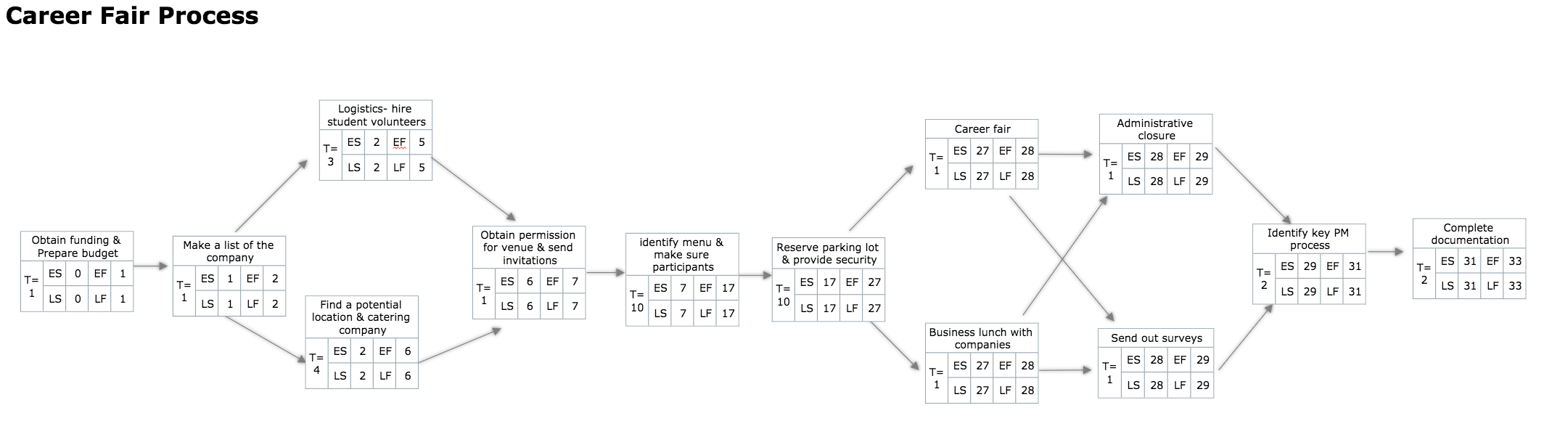

Network & Gantt Chart Analysis Summary

In order to create the network diagram we followed the WBS. We ended up with having 13 activities on our network with the total duration of 33 days. We identified the critical path as A→B→C→D→H→P→S→U→V→Y→Z→AA. After we finalized the network diagram, we began working on the Gantt Chart. Standard working days and resources were entered into the Microsoft Project salary and the staff assignment. Because we entered Saturday and Sunday as non-working days the duration of the project increased. Besides, due to the resource constraint and slack, we had to review the Gantt Chart. As a result, the critical path and slack were changed. Detail In our project we set the minimum requirement for the task assignment and time. This means that the person who is assigned to a task should work on it with at least 25% effort. Moreover, we created the network as considering the minimum work rate. Therefore, we did not need to change the duration when the assignment and the effort rate were entered. However, there was still some room for us to be flexible with time by using slack. This would allow us to maximize the work effort rate to each activity. Firstly, activity G (11 in the Gantt Chart) originally had a 5-day slack. However, because the design manger is required to work on activities G & H, we used the slack of activity G and then we were able to assign the design manager to both of the activities. Subsequently, we noticed that activity D (7) could not be delayed because it is on the critical path. Both, activities D and G, end up having 0 slack. Therefore, activity G (11) became the critical activity although it was not originally on the critical path. Secondly, activities M & N were assigned to the IT manager. However, there was the same problem as with activities G & H. Because the IT manager has to work on both of these activities using 100% effort, activity N was delayed using the slack. As a result of resource constraints, we have two critical paths. A→B→C→D→H→P→S→U→V→Y→Z→AA A→B→C→D→G→S→U→V→Y→Z→AA

The network diagram, which is a visual representation of the project activity flow, is constructed based on the project activities in the WBS. Basically, it tells manager what the best sequence to implement the various activities is. In order to construct the most accurate diagram, the three main questions to be answered are: what activities happen before a particular activity, what activities can take place simultaneously, and what activities happen after a particular activity. From the answers, we determine a meaningful relationship between the activities and thus the sequence of the project.

We have four critical paths. The First one is